**A**

**Project Report**

**On**

**Price Comparison System**

**Submitted by**

***Gaurang R. Patel [210510124018]***

***Kartik Trivedi [210510126035]***

**as**

**Partial fulfilment of Semester VI**

**of Bachelors of Computer Applications**

**for A.Y. 2023-2024**

**Under the Guidance of**

**Internal Guide name: Assistant Professor Jigar Bhavsar  
Company name: Semicolon Solution**

**Submitted To**

**Parul Institute of Computer Application,**

**Faculty of IT & Computer Science**

**Parul University**





**PARUL INSTITUTE OF COMPUTER APPLICATION**

**CERTIFICATE**

This is to certify that ***Gaurang R Patel*** students of Parul Institute of Computer Application, has/have satisfactorily completed the project entitled “***Price Comparison System”*** as a part of course curriculum in BSCIT semester- VI for the academic year 2023-2024 under guidance of ***Assistant Professor Jigar Bhavsar.***

Enrolment Number: 210510124018

|  |  |  |
| --- | --- | --- |
| **Quality of work** | **Grade** | **Sign of Internal guide** |
| **Poor / Average / Good /Excellent** | **B /B+ / A / A+** |  |

Date of submission:

HOD, Principal,

Prof. Hina Chokshi Dr. Priya Swaminarayan



**PARUL INSTITUTE OF COMPUTER APPLICATION**

**CERTIFICATE**

This is to certify that ***Kartik Trivedi*** students of Parul Institute of Computer Application, has/have satisfactorily completed the project entitled “***Price Comparison System”*** as a part of course curriculum in BSCIT semester- VI for the academic year 2023-2024 under guidance of ***Assistant Professor Jigar Bhavsar.***

Enrolment Number: 210510126035

|  |  |  |
| --- | --- | --- |
| **Quality of work** | **Grade** | **Sign of Internal guide** |
| **Poor / Average / Good /Excellent** | **B /B+ / A / A+** |  |

Date of submission:

HOD, Principal,

Prof. Hina Chokshi Dr. Priya Swaminarayan

**Acknowledgement**

*The success and final outcome of this project required a lot of guidance and assistance from many people and we are extremely privileged to have got this all along the completion of our project. All that we have done is only due to such supervision and assistance and we would not forget to thank them.*

*We respect and thank Dr Priya Swaminarayan, Dean, FITCS for providing us an opportunity to do the project work in BCA and giving us all support and guidance, which made us complete the project duly. We are extremely thankful to Mam for providing her support and guidance, although she had busy schedule managing the academic affairs.*

*We would not forget to remember Prof. Hina Chokshi, HOD, BCA department for her encouragement and more over for her timely support and guidance till the completion of our project work.*

*We owe our deep gratitude to our project guide Assistant Professor Jigar Bhavsar, who took keen interest on our project work and guided us all along, till the completion of our project work by providing all the necessary information for developing a good system.*

*We are thankful to and fortunate enough to get constant encouragement, support and guidance from our Parents, all Teaching staffs of BCA Department which helped us in successfully completing our project work. Also, we would like to extend our sincere esteems to all staff in laboratory for their timely support.*

***[Gaurang Patel] [210510124018]***

***[Kartik Trivedi] [210510126035]***

**INDEX**

|  |  |
| --- | --- |
| **Content** | **Page No.** |
| 1. Company Profile | 1 |
| 1. project profile | 2 |
| * 1. Project Definition | 2 |
| * 1. Project Description | 2 |
| * 1. Existing / Legacy System | 2 |
| * 1. Problem Statements | 3 |
| * 1. Needs for New System | 3 |
| * 1. Proposed System | 3 |
| * 1. Scope | 4 |
| * 1. Outcomes | 4 |
| * 1. Tools & Technology used with short justification | 4 |
| * 1. Project Plan | 5 |
| 1. Requirement analysis | 6 |
| * 1. Feasibility Study | 6 |
| * 1. Users of the System | 7 |
| * 1. Modules of the System | 7 |
| * 1. Process Model | 7 |
| * 1. Hardware & Software Requirements | 8 |
| 1. Design | 9 |
| * 1. Use case diagram | 9 |
| * 1. Structured Diagrams | 10 |
| * + 1. Data flow diagram | 10 |
| * + 1. Flow chart | 11 |
| * 1. OOAD Diagrams | 14 |
| * + 1. Class Diagram | 14 |
| * + 1. Sequence Diagram | 15 |
| * + 1. Activity Diagram | 16 |
| * 1. Entity relationship diagram | 17 |
| * 1. Data Dictionary | 17 |
| 1. Data Dictionary | 18 |
| 1. Development Phase | 20 |
| 6.1 Development Phase – I | 20 |
| 6.2 Development Phase – II | 21 |
| 6.3 Development Phase – III | 22 |
| 6.4 Development Phase – IV | 23 |
| 1. Types of Testing | 24 |
| 1. Future Enhancement | 25 |
| 1. Reference & Bibliography | 26 |

1. **COMPANY PROFILE**

**Semicolon Solution**

**IT Development & Marketing**

We’re team of creative minds that work hard to achieve our client’s goal. We have been offering our innovative technical solutions to businesses of all sizes since 2019 that help our clients streamline their operations and increase their profitability.

At Semicolon Solutions, we believe in the power of technology to transform businesses. That’s why we offer a wide range of services that leverage the latest technologies, such as artificial intelligence, machine learning, and data analytics. Our services include software development, web design and development, mobile app development, cloud computing, cybersecurity, and IT consulting.

In our professional carrier, we have been working with various companies and clients from Australia, the USA, the UK, AU Europe, and Canada, just to name a few.

**OUR MISSION**

Our mission is to help our clients achieve their marketing goals through the use of cutting-edge digital marketing strategies and techniques.

We believe that every business is unique, and therefore, we take a personalized approach to every project we undertake. Our goal is to provide our clients with a comprehensive digital marketing strategy that is tailored to their specific needs.

Website: [www.semicolonsolution.com](https://semicolonsolution.com/)

1. **PROJECT PROFILE**
   1. **Project Definition**

**“Price Comparison System”**

This sole motive of this website will be to compare the price of the different product at the same platform at same time to save the time of the consumer. By doing that it will help consumer to take decision quickly.

* 1. **Project description**

This price comparison website to help to compare the price from various e-commerce websites. This Price comparison site is extremely helpful for frequent online shoppers to check prices on different online stores in one place. This system will show you the product prices from different retailers to show you where to buy the product at affordable price. Amazon static website classes are analyzed to get the pricing details. To get the pricing details, the system visits the website based on the ASIN (Amazon Standard Identification Number) number that provided by user. Once prices from all websites are retrieved, it is displayed on our text file in the form of price comparison.

* 1. **Existing System**

This price comparison website to help to compare the price from various e-commerce websites. This Price comparison site is extremely helpful for frequent online shoppers to check prices on different online stores in one place. This system will show you the product prices from different retailers to show you where to buy the product at affordable price. Amazon static website classes are analysed to get the pricing details. To get the pricing details, the system visits the website based on the ASIN number that provided by user. Once prices from all websites are retrieved, it is displayed on our text file in the form of price comparison.

* 1. **Problem Statement**

Every shopper looks for the best deals & discounts before buying any product. Nowadays before purchasing anything the buyers do some online research of the products on the internet. One of the major factors which lead to purchasing of any product is cost or pricing. The buyers tend to compare prices before purchasing any product. But since it is very difficult to visit each & every website for price comparison, there needs to be a solution to automate this process. The Price comparison website project proposed here gathers information on product prices from various websites & presents it to the users. The users can then choose to buy from the best options available. Even Ecommerce traders can use this price comparison website to study their competitors and form new strategies accordingly to attract new customers & stay ahead of their competitors.

* 1. **Needs for New System**

As of now this existing system can only compare the price of different products at one place. But for upcoming times we would like to add discount module that can predict the discount on that particular product so the user can also decide when will they buy the product.

* 1. **Proposed System**

Price comparison websites for online shopping aim to help users find the best deals by aggregating prices from various retailers for the same product. They simplify the shopping process by displaying these prices side by side, enabling consumers to make informed decisions quickly, saving time and money.

* 1. **Scope**

The scope of a price comparison website for online shopping involves providing a comprehensive platform that aggregates prices, product information, and reviews from various retailers. It aims to offer users a convenient and efficient way to compare prices, find the best deals, and make informed purchasing decisions across a wide range of products and categories.

* 1. **Outcomes**

Price comparison websites benefit consumers by saving them time and money through easy price comparisons, encourage competition among retailers, provide transparent information for informed decisions, and offer insights into market trends. However, they can pose challenges for smaller retailers and may sometimes have outdated or misleading information.

* 1. **Tools & Technology Used with Short Justification**
* Web Scraping Tools: To collect data from various e-commerce websites, web scraping tools like Scrapy, BeautifulSoup (Python libraries), or import.io can be employed.
* APIs**:** Utilize APIs provided by e-commerce platforms to access product information and prices.
* Backend Development: Frameworks like Django (Python) can be used to build the server-side logic for data processing and handling user requests.
* Frontend Development**:** Create an intuitive user interface using Ctypes (Implement C data type in python) and OS.
* Price Comparison Algorithms: Develop algorithms to compare prices, taking into account factors like shipping costs, discounts, and availability.
* Hosting and Deployment: Services like AWS, Google Cloud Platform can host your application.
* Analytics and Monitoring: Integrate analytics tools like Google Analytics to track user behavior and website performance. Also, implement monitoring tools to identify and resolve issues.
* Security Measures: Implement security protocols to protect user data and transactions.
* Legal Considerations: Ensure compliance with data privacy laws, terms of service of the websites scraping, and other legal requirements.
  1. **Project Plan**

Our Aim for this project to achieve the consumer’s response towards saving their time to buy the various products. We can also aim to showcase the discount on various products on various platform to increase the ability to help out the customer on their buying.

1. **REQUIREMENT ANALYSIS**
   1. **Feasibility Study**

A feasibility study is simply an assessment of the practicality of a proposed project plan or method. This is done by analysing technical, economic, legal, operational and time feasibility factors. Just as the name implies, you’re asking, “Is this feasible?” For example, do you have or can you create the technology to do what you propose? Do you have the people, tools and the resources necessary? And, will the project get you the ROI you expect?

* + 1. **Technical Feasibility**

Technical feasibility evaluates the technical complexity of the expert system and often involves determining whether the expert system can be implemented with state-of-the-art techniques and tools.

* + 1. **Economic Feasibility**

A feasibility study may also include an economic analysis of the project. The purpose of economic analysis is to determine whether there is an economic case for the investment decision. This assessment goes beyond the items typically included in a financial analysis.

* + 1. **Operational Feasibility**

Operational feasibility is dependent on human resources available for the project and involves projecting whether the system will be used if it is developed and implemented.

* + 1. **Importance of Feasibility Studies**

Feasibility studies can identify the logistical, financial, and market challenges of a proposed project by evaluating:

* What the estimate would be to fund the project
* When the potential business will offer a return on investment
* The market for the proposed product or service
  1. **User of The System**
     + **Admin:** Admin can Update the Website for scraping or delete the website from system. He also can fix the bugs and secure the website.
     + **Search Product**: User can search for the respective product with the help of ASIN number for comparison.
     + **Price Comparison**: User will get the price fetch from static e-commerce websites for comparison.
     + **Output**: The text file which shows the compared data from multiple websites.
  2. **Modules of the System**
     1. **Home page module**

User search the products name to compare the product with other websites.

* + 1. **Output module**

Shows the compared prices and product details across different retailers.

* + 1. **Content management module**

Enables administrators to manage product data, categories, and updates.

* + 1. **User management module**

Controls user permissions and addresses reported issues.

* 1. **Hardware and Software Requirement**
     1. **Hardware Requirement**

|  |  |
| --- | --- |
| **Name of Components** | **Specification** |
| Processor | Intel core I3 or higher |
| RAM | 4 GB or higher |
| Hard Disk | 512 GB or higher |

*Table 3.5.1.* Hardware Requirement

* + 1. **Software Requirement**

|  |  |
| --- | --- |
| **Name of Components** | **Specification** |
| Operating System | Windows 7 or higher |
| Software development Kit | XAMP or WAMP Server |
| Tools & languages | Python, JavaScript, Django Framework, Text Editor (Notepad++ / Sublime Text) |

*Table 3.5.2.* Software Requirement

**CHAPTER 5**

**FLOWCHART**

**5.1 Flowchart of User**

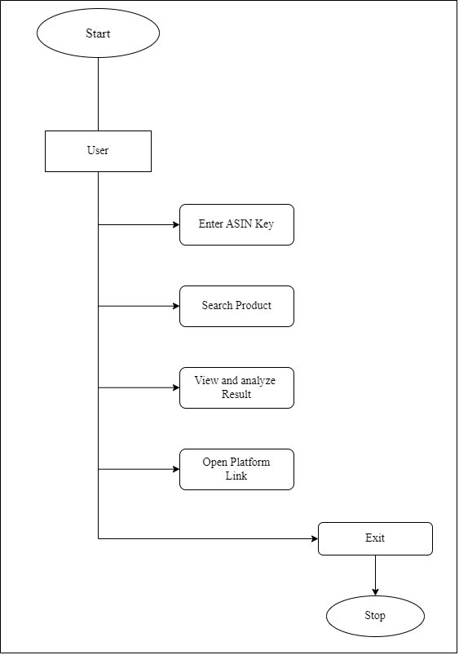

*Figure 5.1 Flowchart of the user*

**Chapter 6**

**DATA FLOW DIAGRAM**

**6.1 Context Level DFD’s**

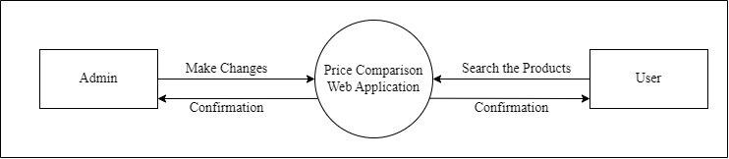

*Figure 6.1* Context Level DFD: 0 Level

**6.2 Level 1 DFD’s (User)**

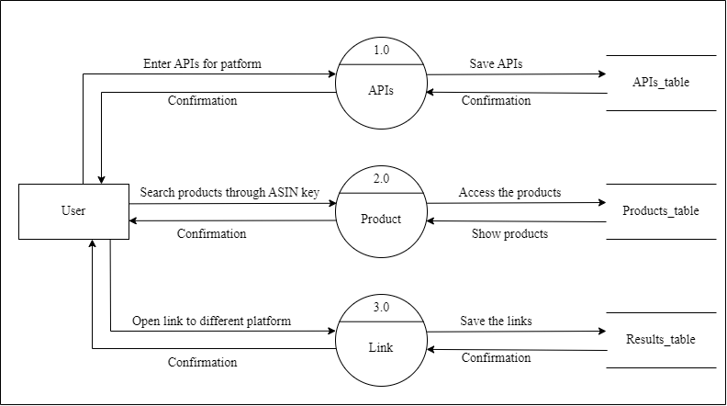

*Figure 6.2* Level DFD: 1 Level (User)

**6.3 Level 1 DFD’s (Admin)**

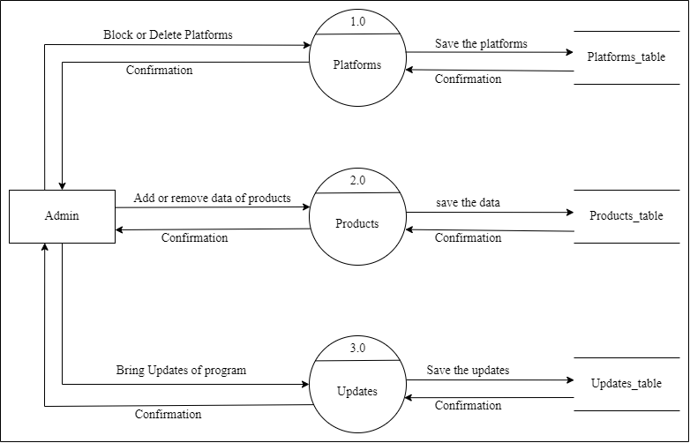

*Figure 6.3 1* Level DFD: 1 Level (Admin)

**Chapter 7**

**USE CASE DIAGRAM**

**7.1 Use Case Diagram for End User**

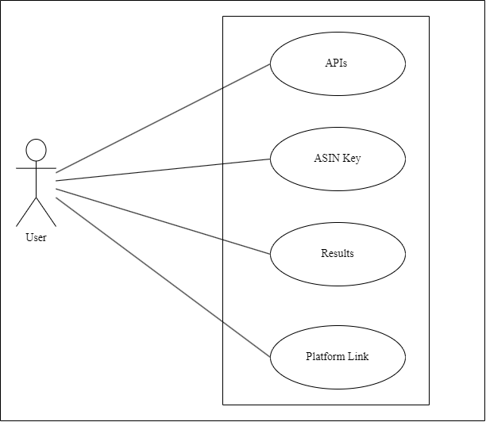

*Figure 7.1* Use case diagram for End user

**7.2 Use Case for Admin**

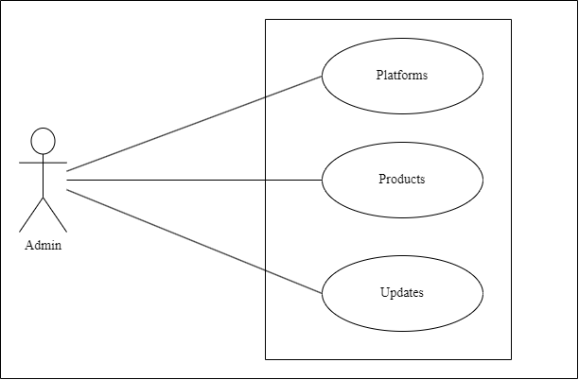

*Figure 7.2* Use case diagram for Admin

**Chapter 8**

**CLASS DIAGRAM**

**8.1 Class Diagram**

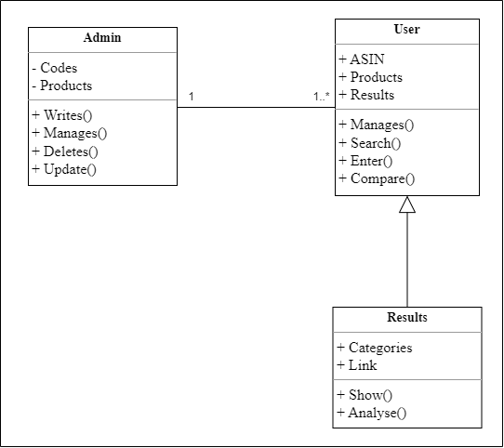

*Figure 8.1* Class diagram

**Chapter 9**

**SEQUENCE DIAGRAM**

**9.1 Sequence Diagram**

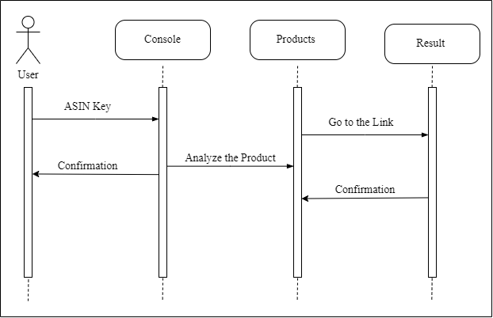

*Figure 9.1* Sequence diagram for End Use

**Chapter 10**

**ACTIVITY DIAGRAM**

**10.1 Activity Diagram for User**

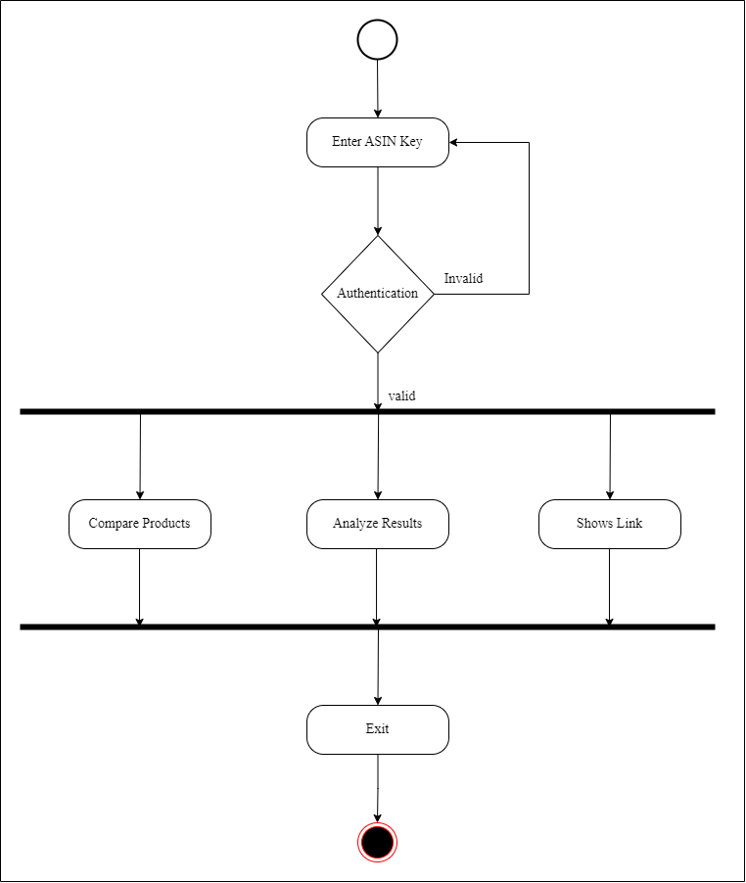

*Figure 10.2* Activity diagram for User

**10.2 Description of Activity Diagram**

Activity diagram is basically a flowchart to represent the flow from one activity to another activity. The activity can be described as an operation of the system. The control flow is drawn from one operation to another. This flow can be sequential, branched, or concurrent.

**Chapter 11**

**ENTITY RELATIONSHIP DIAGRAM**

**11.1 Entity Relationship Diagram**

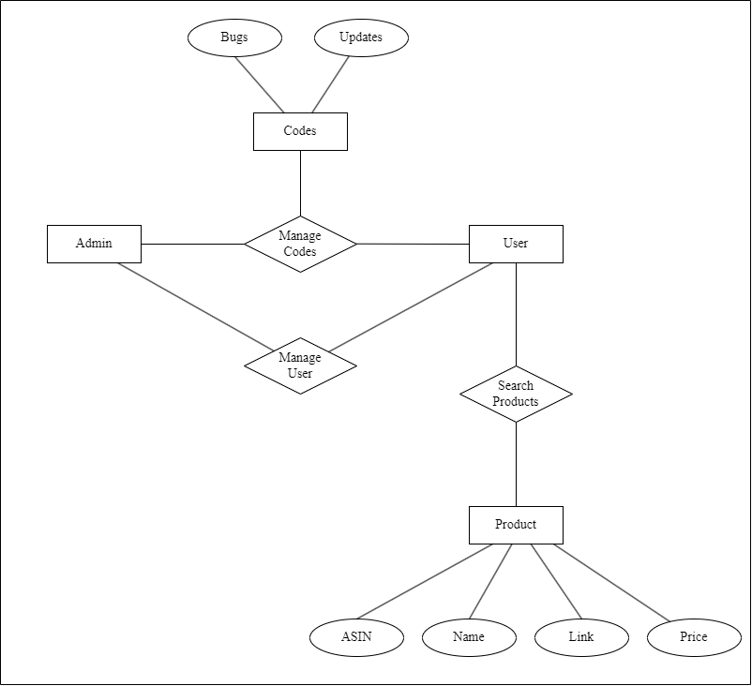

*Figure 11.1* E-R Diagram

**11.2 Description of E-R Diagram**

An entity relationship diagram (ERD), also known as an entity relationship model, is a graphical representation that depicts relationships among people, objects, places, concepts or events within an information technology (IT) system.

**Chapter 12**

**DATA DICTIONARY**

**12.1 Table Name: APIs Table**

Table Description: This table contains the data about amazon products.

|  |  |  |  |  |  |  |
| --- | --- | --- | --- | --- | --- | --- |
| **Sr. No** | **Field Name** | **Datatype** | **Size** | **Description** | **Constraint** | **Example** |
| 1 | Serpkey | String | 256 | API of website | - | f9c7c86d43757a2fb74bc63f001d10f2abad92a9d5d140b1be54b09f1f20316d |
| 2 | amznkey | String | 256 | API of Amazon | - | 1B1611C8CA6E45E6ADC9736FC54AED74 |

*Figure 12.1* figure of APIs Table

**12.2 Table Name: Google table**

Table Description: This table contains the data of google driven platform.

|  |  |  |  |  |  |  |
| --- | --- | --- | --- | --- | --- | --- |
| **Sr. No** | **Field Name** | **Datatype** | **Size** | **Description** | **Constraint** | **Example** |
| 1 | Title | String | 256 | name of product | - | Keyboard |
| 2 | Price | String | 256 | value of products | - | $30.0 |
| 3 | Supplier | String | 256 | name of platform | - | Whatnot |
| 4 | Link | String | 256 | link of the platform | - | <https://www.whatnot.com/listing/TGlzdGluZ05vZGU6MTYzODczODk0> |

*Figure 12.2 Figure o*f Google table

**12.3 Table Name: Output table**

Table Description: This table contains results that shown in output file.

|  |  |  |  |  |  |  |
| --- | --- | --- | --- | --- | --- | --- |
| **Sr. No** | **Field Name** | **Datatype** | **Size** | **Description** | **Constraint** | **Example** |
| 1 | Name | string | 256 | name of platform | - | Whatnot |
| 2 | Price | string | 256 | value of products | - | $10.0 |
| 3 | Link | string | 256 | link of platform | - | <https://www.whatnot.com/listing/TGlzdGluZ05vZGU6MTYzODczODk0> |

*Figure 12.3 Figure o*f Output table

**12.4 Description of Data Dictionary**

A data dictionary is a structured document that describes the metadata of a database, data set or other collection of data. It provides a detailed description of the structure, contents, and relationships of data within a database or data set.

**Chapter 13**

**IMPLEMENTATION**

**13.1 Development Phase-1**

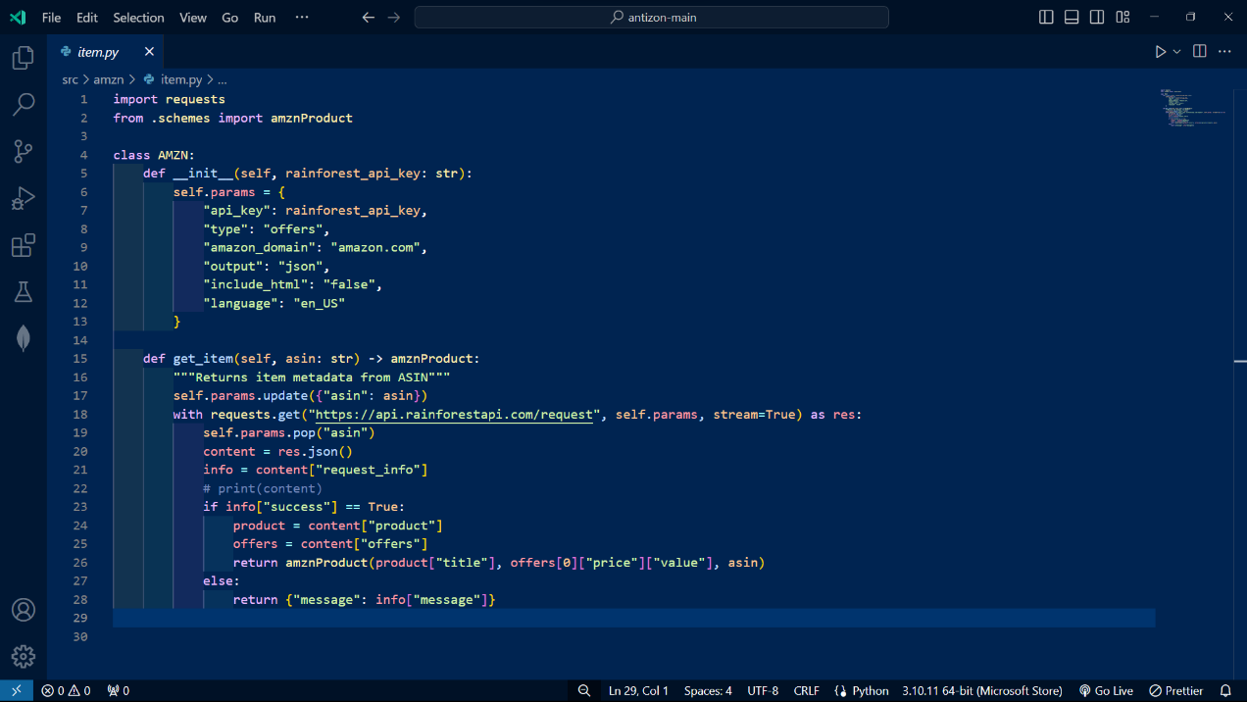

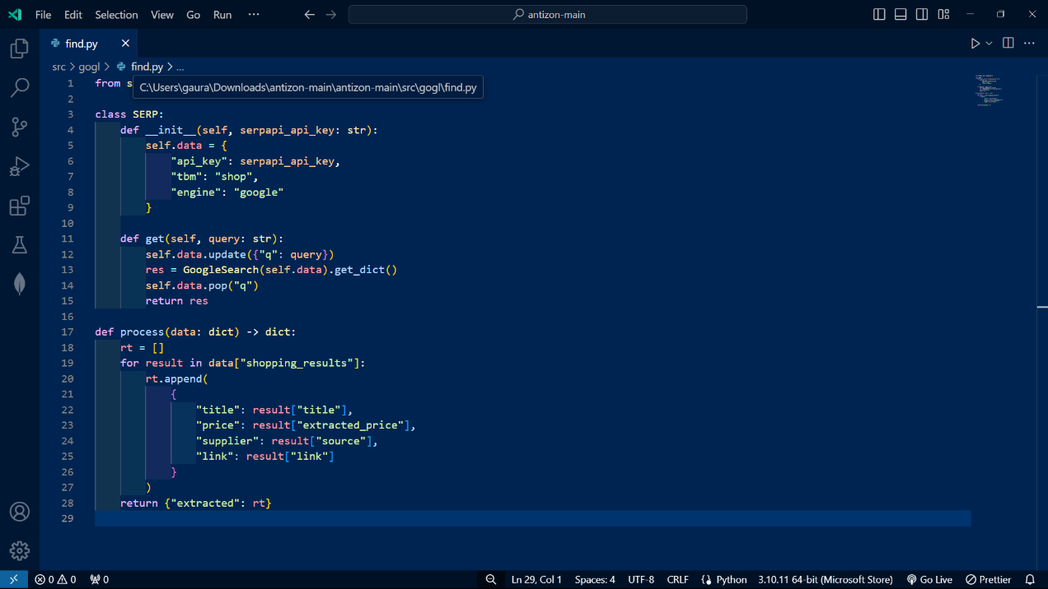

*Figure 13.1 Figure o*f Development phase - I

**13.2 Development Phase-2**

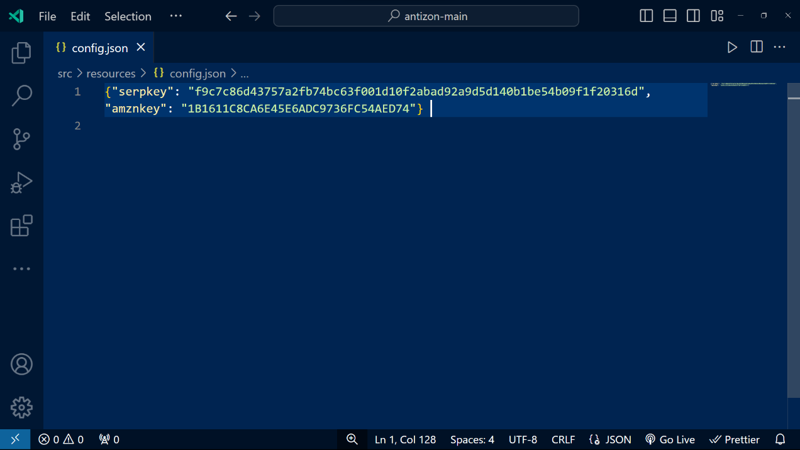

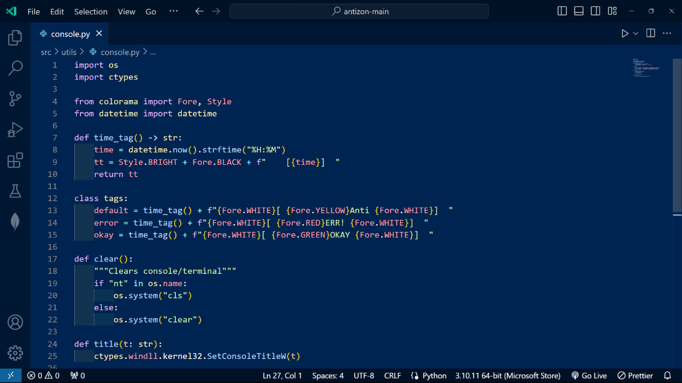

*Figure 13.2 Figure o*f Development phase - II

**13.3 Development Phase-3**

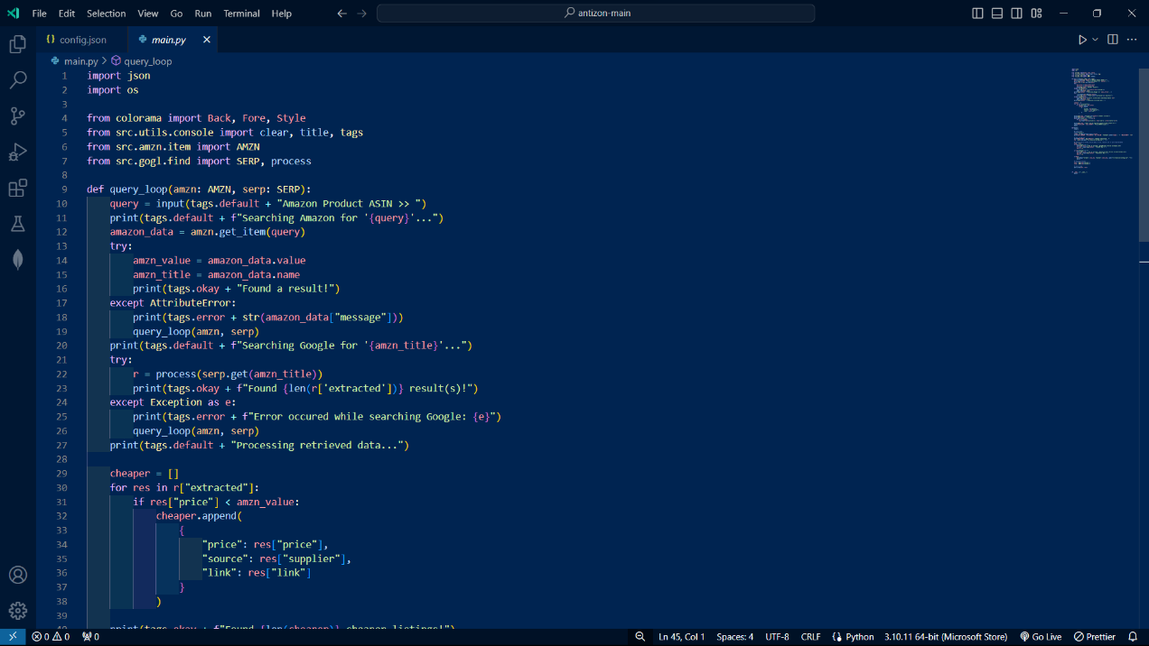

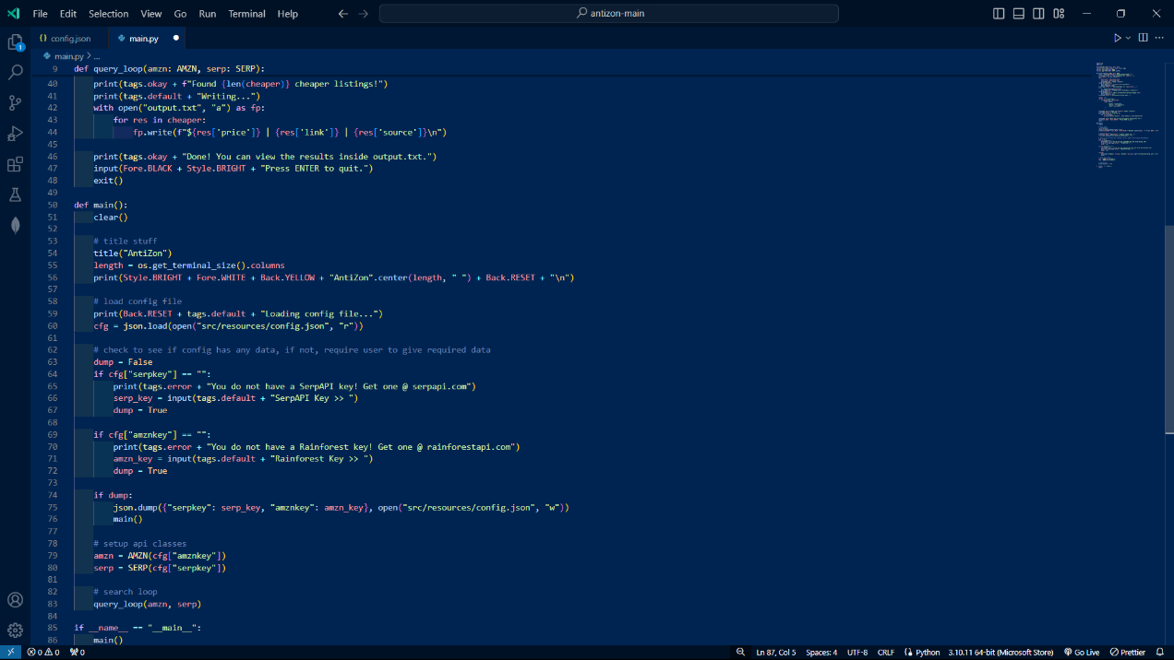

*Figure 13.3 Figure o*f Development phase - III

**13.4 Development Phase-4**

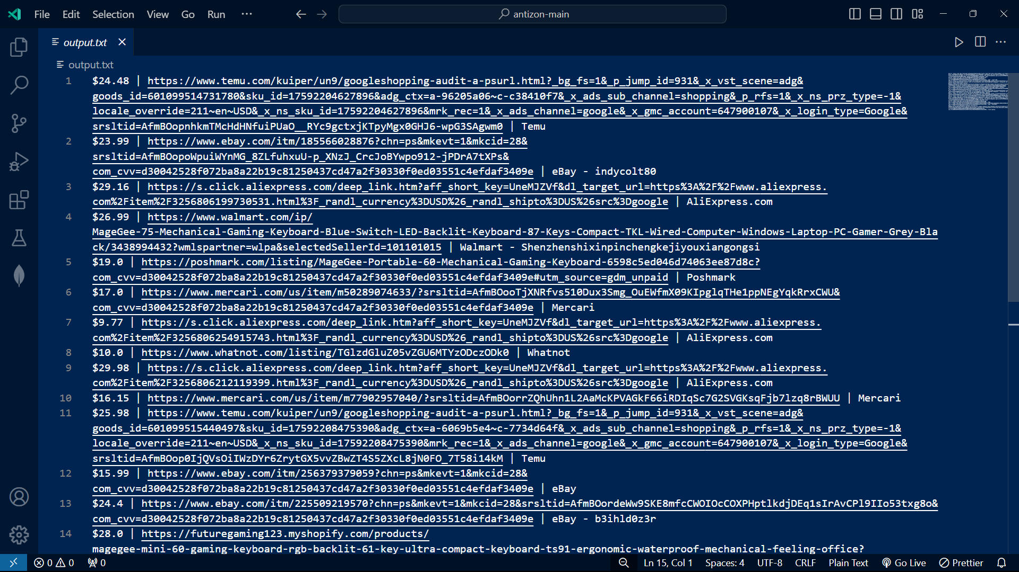

*Figure 13.4 Figure o*f Development phase - IV

**Chapter 14**

**IMPORTANCE AND TYPE OF TESTING**

**14.1 Importance and types of testing**

* Typically Testing is classified into three categories functional testing, non-functional testing or performance testing, and maintenance.
* The important strategies in software engineering are: unit testing, integration testing, validation testing, and system testing.

### **Unit Testing**

### Unit testing is the process of checking small pieces of code to ensure that the individual parts of a program work properly on their own, speeding up testing strategies and reducing wasted tests.

### **Functional testing**

Functional testing checks an application, website, or system to ensure it’s doing exactly what it’s supposed to be doing

### **Accessibility Testing**

Accessibility testing is the practice of ensuring your mobile and web apps are working and usable for users without and with disabilities such as vision impairment, hearing disabilities, and other physical or cognitive conditions

### **Acceptance Testing**

Acceptance testing ensures that the end-user (customers) can achieve the goals set in the business requirements, which determines whether the software is acceptable for delivery or not. It is also known as user acceptance testing (UAT).

### **Interactive Testing**

### Also known as manual testing, [interactive testing](https://www.perfecto.io/solutions/interactive-testing) enables testers to create and facilitate manual tests for those who do not use automation and collect results from external tests.

**Chapter 15**

**FUTURE ENHANCEMENT**

* We will add discount module that can predict the discount on that particular product so the user can decide accurate time to purchase the products.
* We will be adding some collaborative tools on the website.
* We will be developing mobile applications for the same.
* We will be having this system as a proper website.
* We will also ensure the security of the system.

**Chapter 16**

**REFERENCES & BIBLIOGRAPHY**

**Website:**

1. [React](https://reactjs.org)
2. <https://expressjs.com>
3. [https://web.learncodeonline.in](https://web.learncodeonline.in/)
4. [https://learn.mongodb.com](https://learn.mongodb.com/)

**Book:**

1. Beginning Node.js, Express & MongoDB development
2. JavaScript: The Good Parts